

TEMENOS T24

Stream

User Guide

Table of Contents

Font Icons and Images Widget <Code>

Introduction 3

Preface 3

Overview 3

Prerequisites 3

Assumptions 3

Getting Started 3

Installation 3

Adding Fonts Icons and Images Widget 3

# 

# Introduction

## Preface

This User Guide is intended for Developers and provides the step by step instructions for creating a widget to add fonts icons and images, to your presentation.

## Overview

The Fonts Icons and Images widget adds a <i></i> snippet for the icon and generates a text (optional) with the content based on the user selection, within the Widget Details configuration tab.

.

## Prerequisites

The supported platforms are all browsers both Desktop and Mobile.

## Assumptions

It is assumed that you are familiar with the edgeConnect Editors and have working knowledge on edgeConnect.

# Getting Started

## Installation

The prerequisites are:

* Copy **com.temenos.widgets.font.images** folder in your widgets folder (Ex: /{your project/templates/widgets/ }).
* Copy the content of the widget.xml file into your project **widgets.xml** file.

## Adding Fonts Icons and Images Widget

To add fonts icons and images widget:

1. In the **Presentation Editor**, add a font icon or image and double click it. The **Font – Images Properties** dialog opens.
2. In **Display Type**, add **Font-Images** type.
3. In the **Widget Details** tab, you have to set up the widget settings.

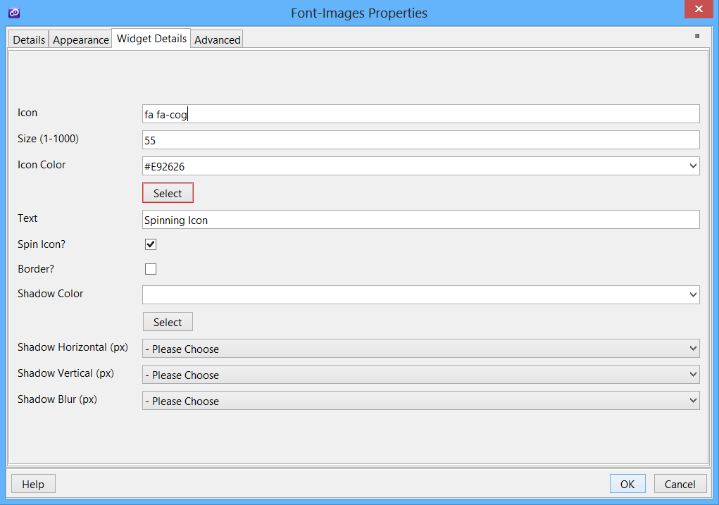

* **Icon** – The name of the icon. You can see a full list of the naming at: <http://fortawesome.github.io/Font-Awesome/icons/>
* **Size** - The size of the icon in pixels.
* **Icon Color** - Select the color of the icon.
* **Text** - Add a text on the right side of the icon.
* **Spin Icon** - Add a spinning effect to the icon.
* **Border** - Add a border to the icon.
* **Shadow Color** - Automatically add a shadow and select the color.
* **Shadow Horizontal** - Select the size of the horizontal shadow.
* **Shadow Vertical** - Select the size of the vertical shadow.
* **Shadow Blur** - Select blue size.

The following example displays the icons.

